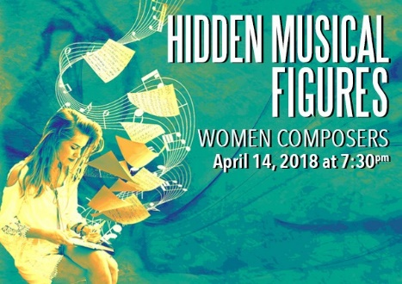
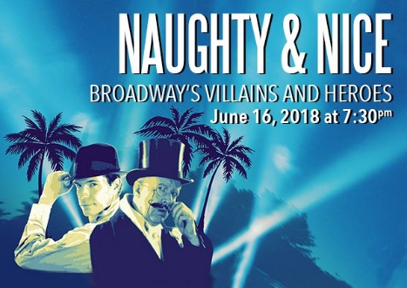

Do You Love To Sing?
Masterworks Choral Ensemble (MCE) is looking for talented and dedicated singers as we prepare for the 2017-2018 season – our 37th! We have openings in all sections.
MCE has a long history of choral excellence, community service and music education in south Puget Sound. We perform concerts in October, December, April and June at the Washington Center for the Performing Arts in downtown Olympia. We also host the popular Harmony Sweepstakes A Cappella Festival in March.

Our 2017-2018 concert schedule is at left

Important upcoming dates are:
August 1, 2017 New Member Auditions*
August 26, 2017 First season rehearsal and retreat*

Contact our New Member Coordinator, Christine Spaulding (chrisspa@comcast.net, 360-943-3364) to arrange an audition time.

Auditions and rehearsals take place at First United Methodist Church, 1224 Legion Way SE, Olympia.

Learn more about Masterworks at our website MCE.org.
I hope you will consider auditioning to join us. You will be glad you did!

Gary Witley
Artistic Director and Conductor

“If I cannot fly, let me sing.” ― Stephen Sondheim

Masterworks Choral Ensemble
2017-2018 Chorus Audition Questionnaire
Date of Audition _______________Time of Audition: _____________
Name ______________________________________________________________________________________
Address____________________________________ City ___________________ Zip (+4) _________ + _______
Home phone ______________________ Work phone ______________________ Cell _____________________
Email address _______________________________________________________________________________
Employer or Business Name & Address: ___________________________________________________________
____________________________________________________________________________________________
Your Occupation ______________________________________________________________________________
Height ________ Name of Spouse/Partner _________________________________________________________
The information you provide on this form will be used only for administrative purposes by MCE, except that, with your permission, your name will be added to our mailing list. That list may be shared with other South Sound arts organizations. ___________OK, add me to the mailing list. ____________Don't add me, I'm already on the list.
1. How did you find out about Masterworks Choral Ensemble? ___________________________________________
2. Have you ever attended one of our concerts? _________ When? ______________________________________
3. Please list choral/vocal experience in the last 5 years: ________________________________________________
4. Have you ever studied voice privately? _______ When & for how long? __________________________________
Currently studying with _____________________________________________________________________
5. Do you play the piano? _____
If so, could you lead a section rehearsal at the keyboard (play your vocal part)? ____________
6. Do you play any other instrument(s)? ______ If yes, please list:________________________________________
7. How will you learn/practice your music outside of rehearsals? __________________________________________
8. Please indicate any languages (other than English) you can claim some ability with:
Latin German French Hebrew Italian Other:
9. We are only seeking members that will commit to ALL concert dates for the MCE season. The 2017-2018 concert dates are Oct 14, 2017, Dec.2, 2017, April 14, 2018, and June 16, 2018. Can you foresee any conflicts that might keep you from singing in any of these concerts? ______ If so, please explain. __________________________
10. Will you be able to attend our Saturday retreats from 9am-3pm (9/26/17 & 1/13/18)_______________
12. Would you be interested in auditioning for solos? __________________________________________________
13. Please circle your voice classification, if you know it: (1st = higher, 2nd = lower)
1st Soprano 2nd Soprano 1st Alto 2nd Alto 1st Tenor 2nd Tenor 1st Bass 2nd Bass
Non-Discrimination Statement: Masterworks Choral Ensemble does not advocate, support, or practice discrimination based on race, sex, age, physical ability, sexual orientation, religious or political beliefs, marital or family status, national or ethnic origin. This applies to all of Masterworks programs and activities.
.

