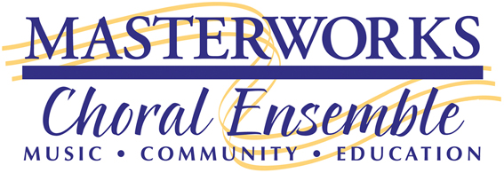

2017-2018
BOARD OF DIRECTORS
OFFICERS
Tim Horine
President
Mary Tennyson
Vice-President
Phyllis Villeneuve
Treasurer
Ana Martin
Assistant Treasurer
Candace Williams
Secretary
BOARD MEMBERS
Abby Bowers
Kayla Emerson
Doreen Hodgkins
Mark Rhodes
Christine Spaulding
EX OFFICIO
Gary Witley
Artistic Director
Lisa Skelley
Business Manager

February 20, 2018
Dear Music Educator:
Music teachers and performing arts directors of the South Sound are invited to select talented students to participate in the annual "Youth Music Competition” sponsored by Masterworks Choral Ensemble (MCE). This event, now in its fifteenth year, is one way MCE offers cultural enrichment experiences to youth in our communities. This year's event will be held on May 5, 2018 in the Black Box at the Kenneth J. Minnaert Center for the Arts at South Puget Sound Community College.
Students from 3rd through 12th grade are eligible to participate. Judging takes place in three separate age groups: grades 3-5 (elementary); 6-8 (middle); and 9-12 (high school). A student can win only ONCE in any level, and a student may not compete the year following their win, even if they switch levels.
The winner in each level will receive a $200 cash award and the opportunity to perform at an MCE event at the Washington Center for the Performing Arts. Their performances were delightful, and concertgoers were enthusiastic in their appreciation! These students truly give us confidence in the future of the arts in the South Sound.
To reserve a spot in the competition, students must complete and submit an application form by the deadline, April 14, 2018. An application form is enclosed. Additional copies of the application form can be found on our website (www.mce.org > Education > Youth Music Competition). Students must also provide five copies of the music they will perform for their adjudicating panel to use – photocopies are encouraged. The copies will be destroyed at the end of the competition. Students who submit their applications by mail may enclose their music with their applications. All others must provide copies of their music to the panel before they perform. This will ensure the most productive judging and feedback for each participant.
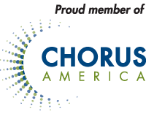
We look forward to receiving applications from your talented students. You can find more information on the MCE Web site, www.mce.org. You may also contact Debbie Robinson at (360) 584-0114.
Thank you for supporting this wonderful event!

Sincerely,
Debbie Robinson and Pam Grigsby-Jones
Youth Music Competition Co-chairs

