Ad Spec Sheet
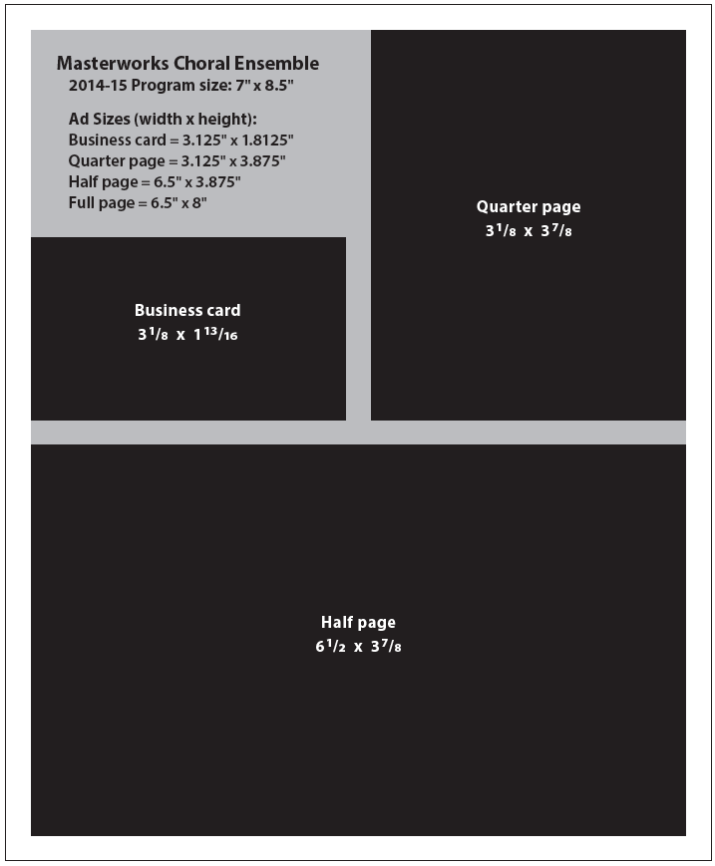
Masterworks Choral Ensemble
2018-2019 Program size: 7” x 8.5”
For MCE advertising and sponsorship information, please contact Ana Martin 360.570.3453. Please match our ad specifications, and provide print-ready files in PDF format. Be sure all images, graphics and fonts are embedded in your PDF. If you need ad assistance, our graphic designer is available to answer your questions or create a professional ad for you. Please contact Jill at Jill Carter Design, jill@jillcarterdesign.com or 360.789-7099.

