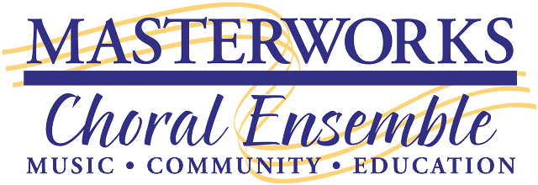
2018-2019 ADVERTISING CONTRACT
Name of Advertiser
Contact Person
Mailing Address
Telephone |  | Email
2018-2019 Concert Season
SACRED ELEMENTS – Earth, Air, Fire and Water
October 13, 2018

YULETIDE CELEBRATION
December 1, 2018

HARMONY SWEEPSTAKES
March 9, 2019

STRENGTH and SERENITY – Leavitt’s Missa Festiva and Faure’s Requiem
April 13, 2019

TORCH SONGS – Songs of Love
June 15, 2019
Ads Ordering Chart: Put a check by your chosen Ad size
Business Card $300
Bonus: 1 ticket voucher (up to a $26 value)
Quarter Page $450
Bonus: 2 ticket vouchers (up to a $52 value)
Half Page $675
Bonus: 3 ticket vouchers (up to a $78 value)
Full Page $1000 (Free to a concert sponsor with donation of $5,000 for their sponsored concert)
Bonus: 4 ticket vouchers (up to a $104 value)

Total Payment Enclosed $ ____________________________

Deadline for Ad in October Concert Program is SEPTEMBER 10, 2018
Email your print ready Ad (see separate Spec Sheet) to info@mce.org

Signatures
Advertiser Representative____________________________________ Date _______________
Masterworks Representative _________________________________ Date _______________

For MCE advertising information, please contact Ana Martin at 360.570.3453
- Please match our ad specifications, and provide print-ready files in PDF format. Be sure all images, graphics and fonts are embedded in your PDF.
- If you need ad assistance, our graphic designer is available to answer your questions or create a professional ad for you. Please contact Jill Carter at: jill@jillcarterdesign.com

