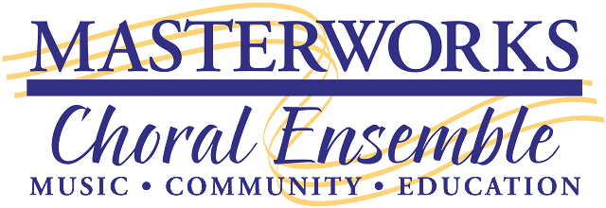

2018-2019 CONCERT SEASON
DONOR and/or SPONSOR CONTRACT
Contact Person: _______________________________________________________
Business or Company Name: _____________________________________________
Street Address: ________________________________________________________
City______________________________________ Zip _______________________
Phone: _______________________ E-mail: _________________________________
Donation Type

GENERAL FUND DONATION ($10 to $999) AMOUNT: $ _________________
TARGETED DONATION AMOUNT: $ __________________
*Please designate your donation one of the categories below. You may also divide your donation among the categories.
$_________ MCE General Fund $_________ Youth Music Competition $_________ Fund a Chorister

CONCERT SPONSOR ($1000 - $4,999) AMOUNT $ ___________________
Select the concert:
☐ Oct. 13, 2018: Sacred Elements – Earth, Air, Fire and Water
☐ Dec. 1, 2018: Yuletide Celebration
☐ Mar. 9, 2019: Harmony Sweepstakes A Cappella Festival
☐ Apr. 13, 2019: Strength and Serenity – Leavitt’s Missa Festiva and Faure’s Requiem
☐ Jun. 15, 2019: Torch Songs – Songs of Love

SEASON SPONSOR ($5,000+) AMOUNT $ ___________________

Payment Information:
❑ Check (Make check payable to MCE) ❑ Visa or MasterCard
Name on card: ______________________________________
Card #: ____________________________________ CVC Code:_____ Expiration Date: __________
Signature: __________________________________________
Miscellaneous Information:
- *Mail the first page of this form to: Masterworks, P.O. Box 1091, Olympia, WA 98507
- *Questions: Leave a message at 360-491-3305 and we will get back to you.
- *All donations are tax deductible. MCE’s federal tax identification number is: 91-1240717.
- *MCE will mail you a confirmation receipt of your donation once it is processed.
- *Please make a copy of this contract for your records

