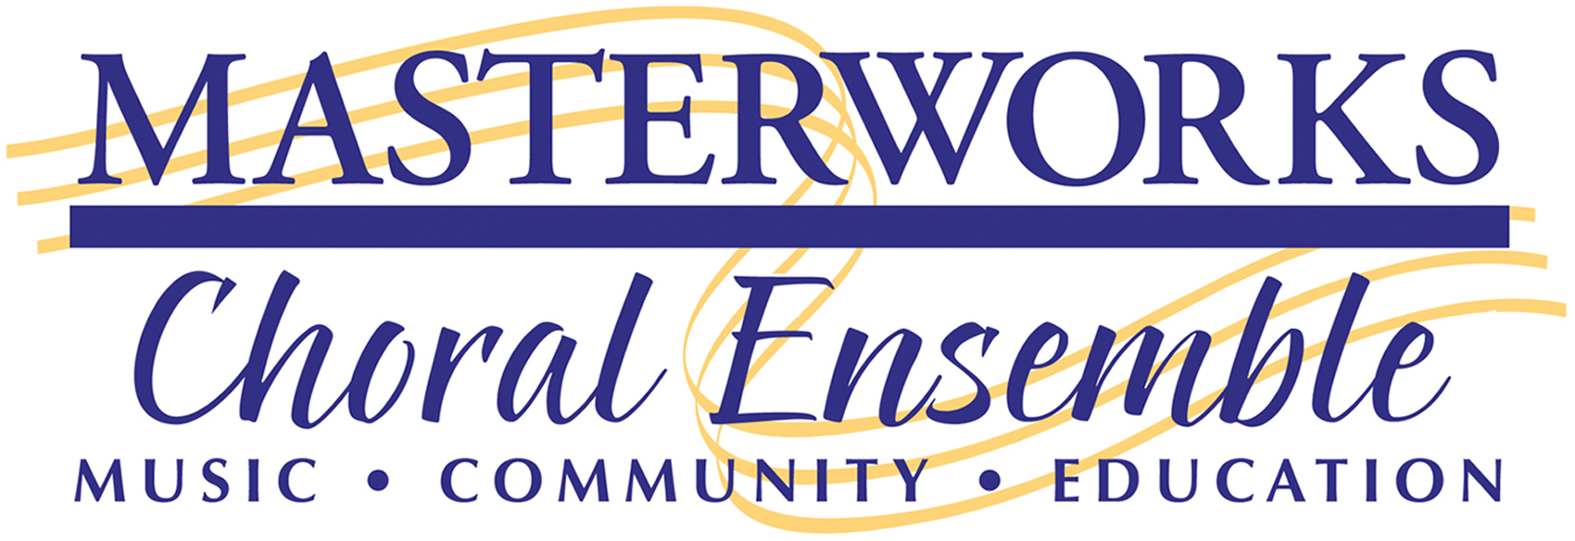

2018 PNW Harmony Sweepstakes A Cappella Festival

Information

General Instructions
• Completed application packets must be received by February 6, 2018. Note: If you competed in the last two previous PNW Regionals, you do not need to resubmit a bio, photo or audio sample as long as you still have the same personnel. If this applies to you, just complete the application and mail it to us with the application fee.
• Mail your packet to Masterworks, Attn: Harmony Sweepstakes, PO Box 1091, Olympia, WA 98507
• Include an entry fee of ten dollars per person with your application. Please make checks out to MCE.
• Groups will be selected and notified soon after February 6, 2018.
• If your group is not selected, all materials will be returned.
Sorry, but we can only consider applications that are complete in every detail. Please make sure you supply all requested information.
Special note: Groups that have “signed up” via the National Harmony Sweepstakes website have in actuality only notified the national office that you are interested in applying. They then notify us (the PNW Regional Office) and we contact you. The best and fastest way to apply is to complete this application. This information is also available on our website at: http://mce.org/event/harmony-sweepstakes/

General Information
• The PNW Regional Harmony A Cappella Sweepstakes competition will be held Saturday, March 10th, 2018, 7:30pm at the Washington Center for the Performing Arts in Olympia, Washington.
• Local radio personality Smilin’ Jay (KGY 96.9 FM), returns as our emcee.
• Masterworks Choral Ensemble and Primarily A Cappella sponsor this event.
• The competition is open to a cappella groups of three to twelve (NEW) members.
• All styles of a cappella are welcome, with an emphasis on innovative and original material.
• Groups will be judged on musicality, originality and overall performance.
• The rulebook is available for download at our website: : http://mce.org/event/harmony-sweepstakes/
• The National competition will be held on May 19, 2018 in San Rafael, California.
• Regional winners receive a round trip airfare stipend*, two night’s accommodations and ground transportation to the national finals. Additional regional and national prizes may be supplied by Primarily A Cappella. (*Airfare stipend is calculated from Seatac for a maximum of 8 members, with no special changes for any members of the group, booked at least six weeks in advance of the national finals. This amount will be calculated by Masterworks and paid to the winning group. The winning group then arranges for their own airfare. Receipts for ground transportation (for a maximum of 8 members) are submitted for reimbursement.)
NOTE: 2018 Regional winners, upon accepting 1st prize, agree to attend the National Finals in San Rafael in May 19, 2018, and host the following year’s PNW regional contest on Saturday, March 9, 2019. All financial awards (airfare, lodging, ground transportation) are for a maximum of 8 members.

2018 PNW Harmony Sweepstakes A Cappella Festival

Application
1. Group Name: ____________________________________________________________________________
Please do not use aliases. Use the group name you intend to use at Harmony Sweepstakes.

2. Contact Name: ____________________________ Street Address ____________________________________

City/Zip: _________________ Phone: ( )_______________ Fax: ( )___________ E-mail: _______________

If your group has a web site, please give us the web address: _____________________________________________

3. List the first and last name of each member of your group.

1. | 2. | 3. | 4.
5. | 6. | 7. | 8.
9. | 10. | 11. | 12.

4. Write a short biography of your group (not individual bios) that is approximately 125 words long. Please send it in one of these formats (listed in our order of preference): (1) via e-mail to: gwitley@visionseed.com, or (2) On CD in WORD or as a straight text file, or (3) send a hard copy via snail-mail.
5. Send us a photo of your group. Send us a professional hard-copy COLOR photo or a high resolution COLOR digital image. The important thing is getting to us the most professional photo possible. Please do not send us a photo you have printed yourself using your computer. Also, please do not “Photoshop” your logo or group name on your digital image or print it on your actual photo. Photos must not include any text, group name or logos. Let our professional graphic designer do any necessary editing as necessary. Remember: anything less than a professional photo may result in your group looking amateurish in the program compared to the other group’s professional photos. We want all groups to look equally great!
6. You will need to submit an audio sample of your group. This could be a audio CD, an MP3 file or a link to your website or YouTube video, etc.. We cannot accept recordings in any other format. The better the quality of the recording, the better chance your group has of being selected to compete. Please send a minimum of 2 songs/links (maximum 3) to demonstrate the versatility of your group. If you send a full-length CD, be sure to indicate the tracks you want used for the audition process. If you competed in the 2017 contest AND your membership has not changed you do not need to send us an audio sample.
7. Enclose a check for the nonrefundable application fee for $10 per person in your group. Make checks out to MCE and write Harmony Sweeps on the check memo line. Unfortunately, we cannot accept any other method of payment at this time.
8. Please read, sign and return this entire agreement, keeping a copy for your files:
A. By signing this form, we, the group applying, hereby grant permission to the PNW Regional Harmony Sweepstake A Cappella Festival (PNW RHSACF) to record our performance on audio and/or video, and to use these, the group’s name and the likeness of any member, as well as the photos provided, for promotional purposes. Such recordings and video are the property of the PNW RHSACF, and the PNW RHSACF is expressly granted the right to manufacture, sell and publicly perform or broadcast a commemorative recording of the event including our contribution. Performing groups will receive a promotional copy of any recording.
B. If selected as the regional winner, our group agrees to attend the National Finals in San Rafael, California, in May 19, 2018 and host the following year’s 2019 PNW festival on Saturday, March 9, 2019, at the Washington Center for the Performing Arts in Olympia. We understand that our group must provide our own transportation as hosts for the 2019 PNW event in Olympia. As the host group for 2019, lodging accommodations (double occupancy for up to 8 members) and dinner the evening of the event will be provided by Masterworks.
C. If we are elected as the 2018 PNW regional winner and are unable to return to host the 2019 PNW Regional Harmony Sweepstakes A Cappella Festival, we agree to provide a replacement group, suitable to PNW RHSACF, at no additional expense to PNW RHSACF or Masterworks.
D. If selected as the 2018 PNW regional winner and we are unable to compete in the May 19, 2018 National Finals, we agree to help provide a replacement group, suitable to PNW RHSACF, at no additional expense to PNW RHSACF or Masterworks.
E. We acknowledge that the prize package for the 1st place winners is: round trip airfare stipend*, two night’s accommodations and ground transportation to the national finals (see Airfare stipend on the first page) for a maximum of 8 members. Additional regional and national prizes may be supplied by Primarily A Cappella.
We, ______________________________________ (group name) agree to conditions A, B, C and D of the above agreement.
Signature of authorized representative: ____________________________
Date _______________ Print name ______________________
Please feel free to copy this application for groups you know that might be interested. You can also direct friends to download a PDF version of this application form from our web site at www.MCE.org. Follow the links to the Harmony page. We look forward to another exciting sold-out event! Thank you for your interest in the PNW Regional Harmony Sweepstakes A Cappella Festival!
Return your completed packet to:
Masterworks Choral Ensemble
Gary Witley, PNW Harmony Sweepstakes Regional Director
PO Box 1091
Olympia, WA 98507-1091

Direct any questions to:
Gary Witley
Masterworks Choral Ensemble
gwitley@visionseed.com (best way to reach me)
360-491-3305 (Masterworks message line)
360-264-8301 (Witley’s home business line)

Remember applications that are complete in every detail receive higher consideration when selecting groups. Please make sure you supply all needed information as outlined above. Good luck!

Sincerely,

Gary Witley
Regional Director
PNW Harmony Sweepstakes

